Objective:
Use Subqueries, CTEs, and Window Functions to analyze sales data from the Superstore dataset.
Tasks
Step 1: Setup Data
- Import the Superstore dataset into a table named superstore_raw.
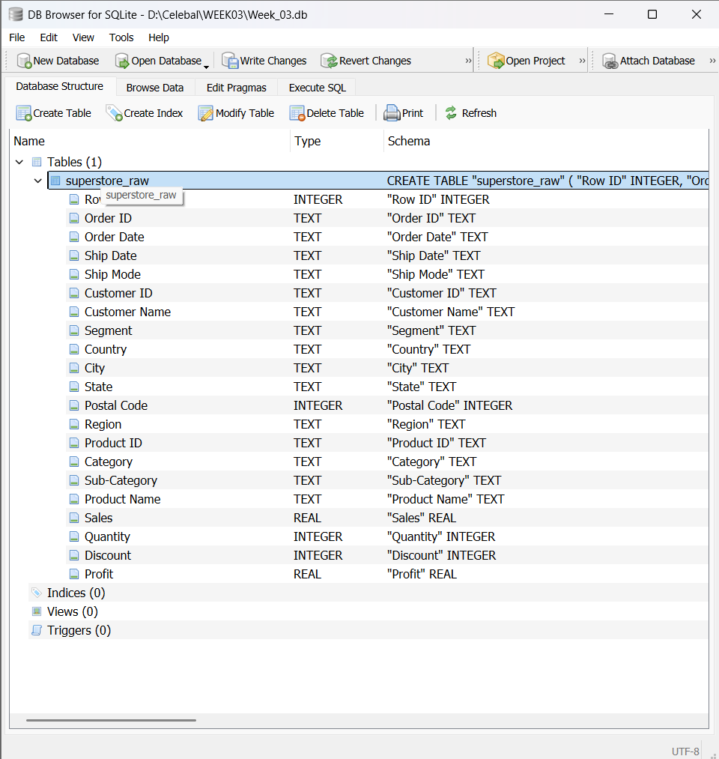
- Create these 3 tables from it:
- customers
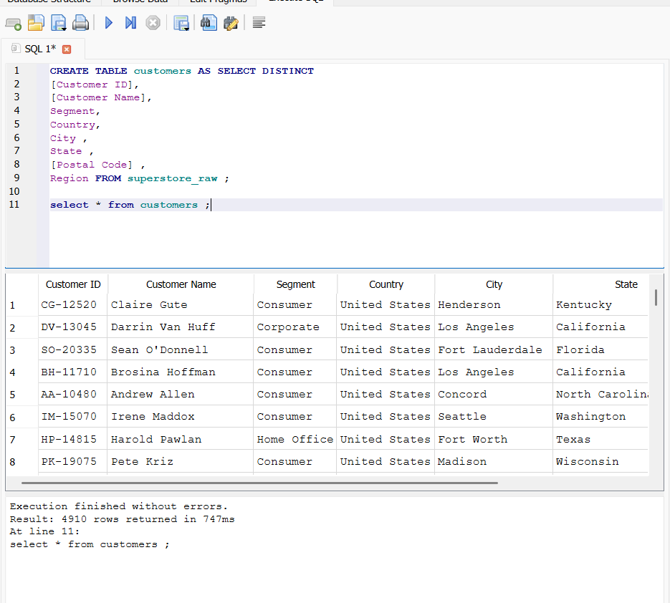

b. products 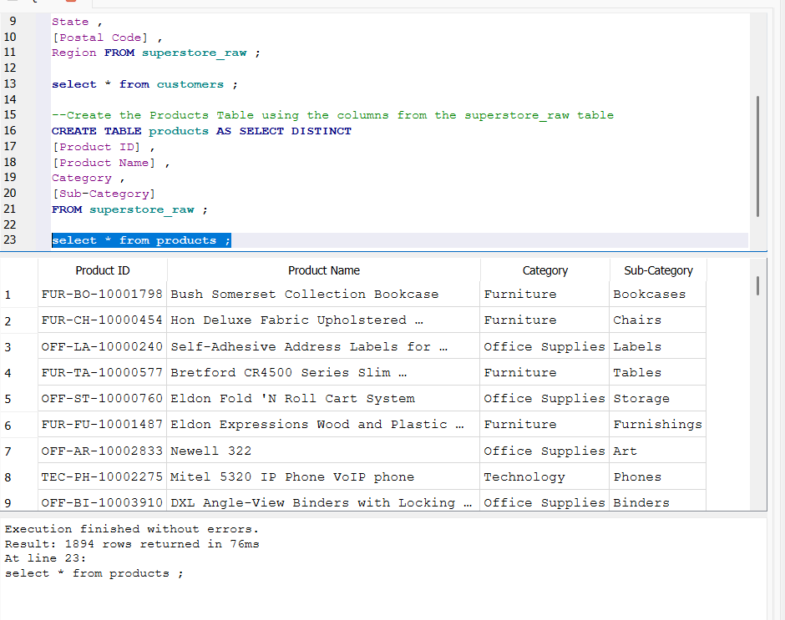
c. Orders
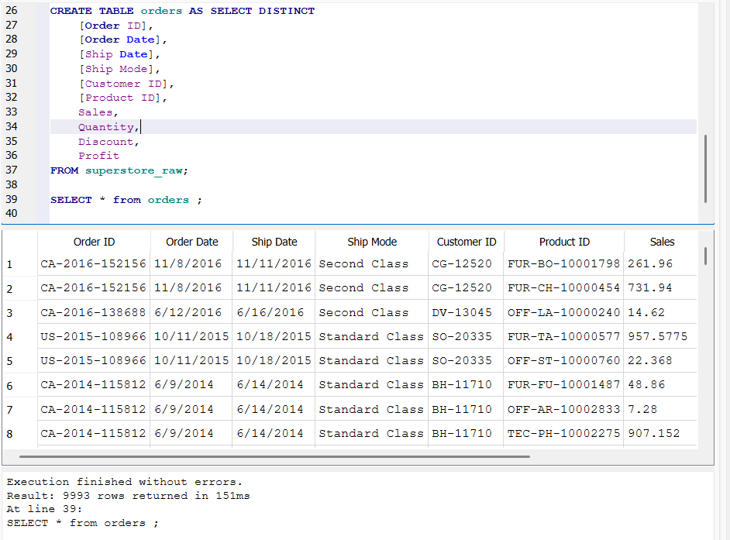
Step 02 Perform Required Queries
- Find all orders where sales are greater than the average sales
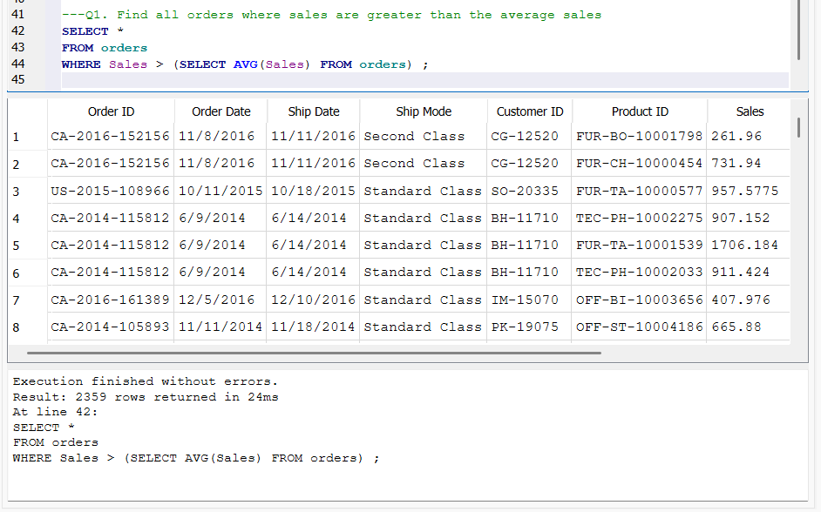
Orders with sales greater than the average sales value were identified using a subquery. These orders represent high-value transactions that contribute significantly to the company's overall revenue.

- Find the highest sales order for each customer.
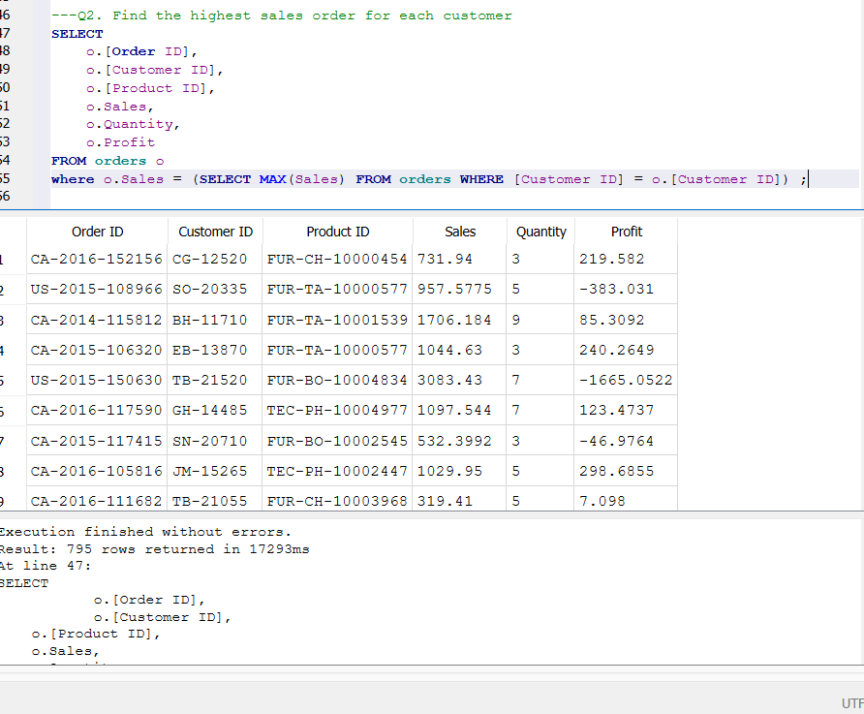
The highest-value order placed by each customer was identified. This analysis helps understand the maximum purchasing capacity of individual customers.

- Calculate total sales for each customer.
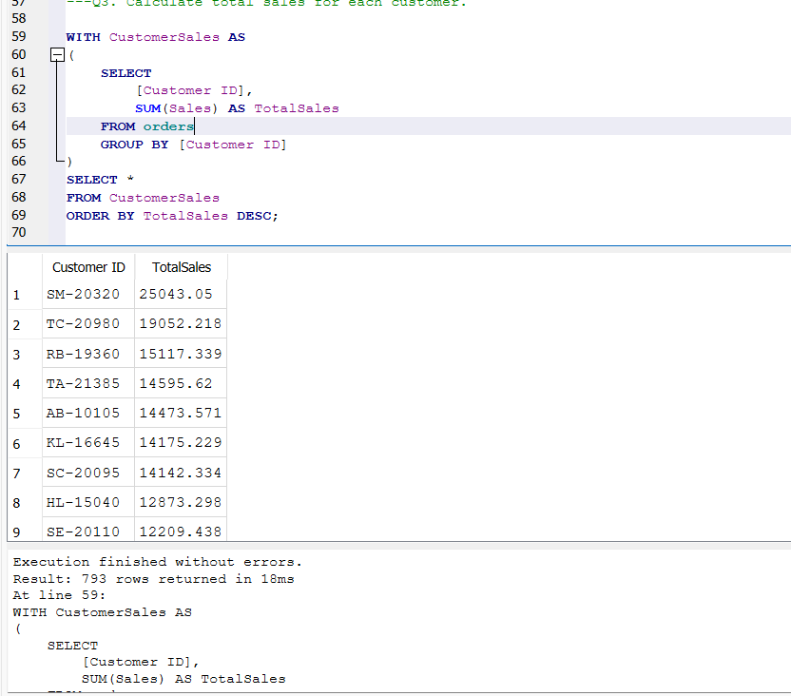
The total sales generated by each customer were calculated using a Common Table Expression (CTE). This provides a clear view of customer contributions to overall business revenue.

- Find customers whose total sales are above average
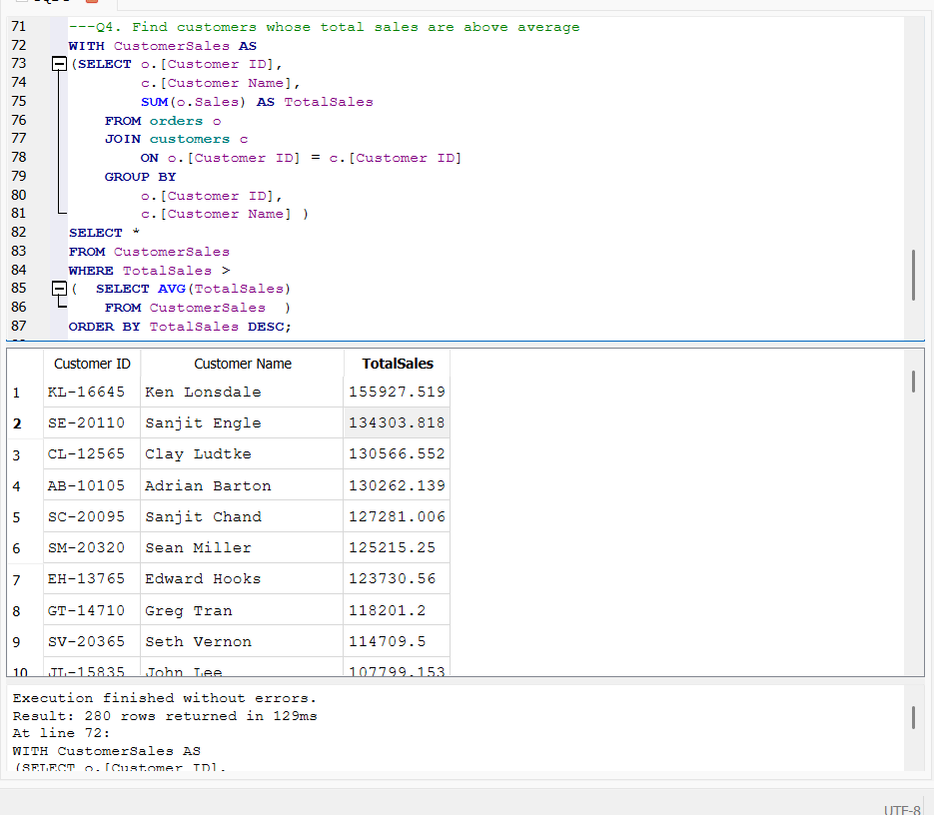
Customers whose total sales exceeded the average customer sales were identified. These customers are valuable to the business and should be prioritized for customer retention and loyalty programs.

- Rank all customers based on total sales

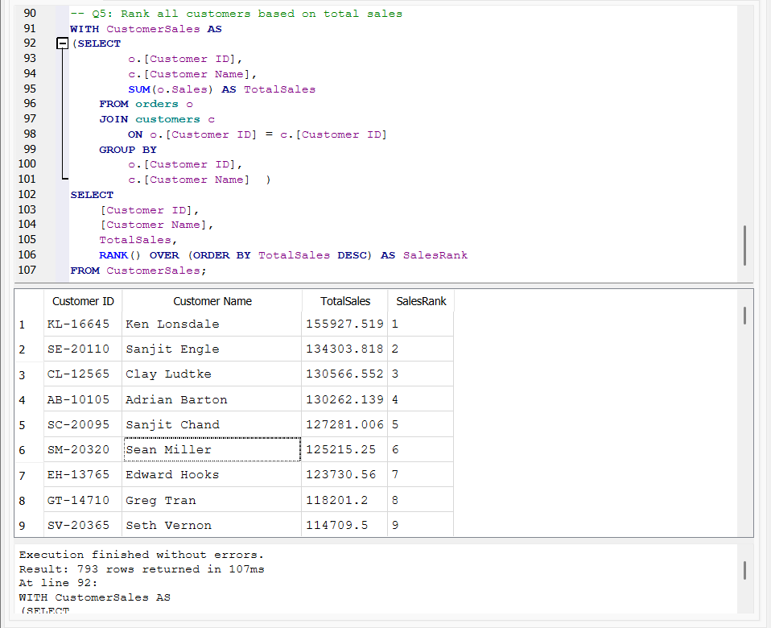
Customers were ranked based on their total sales using the RANK() window function. This makes it easy to identify the highest-performing customers.

- Assign row numbers to each order within a customer
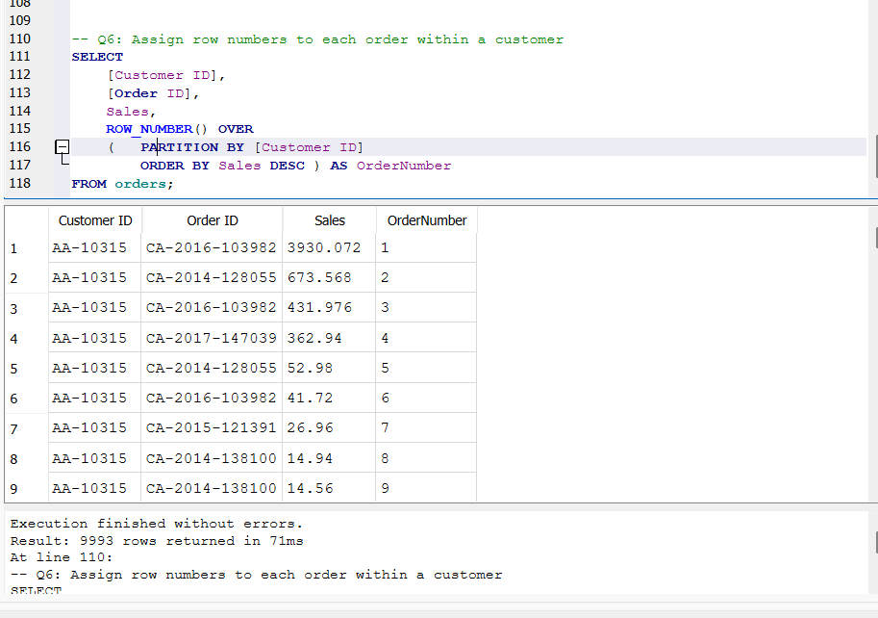
ROW_NUMBER() with PARTITION BY was used to assign a sequence number to each order within a customer. This helps analyze each customer's order history and highest-value purchases.

7. Display Top 3 Customers Based on Total Sales
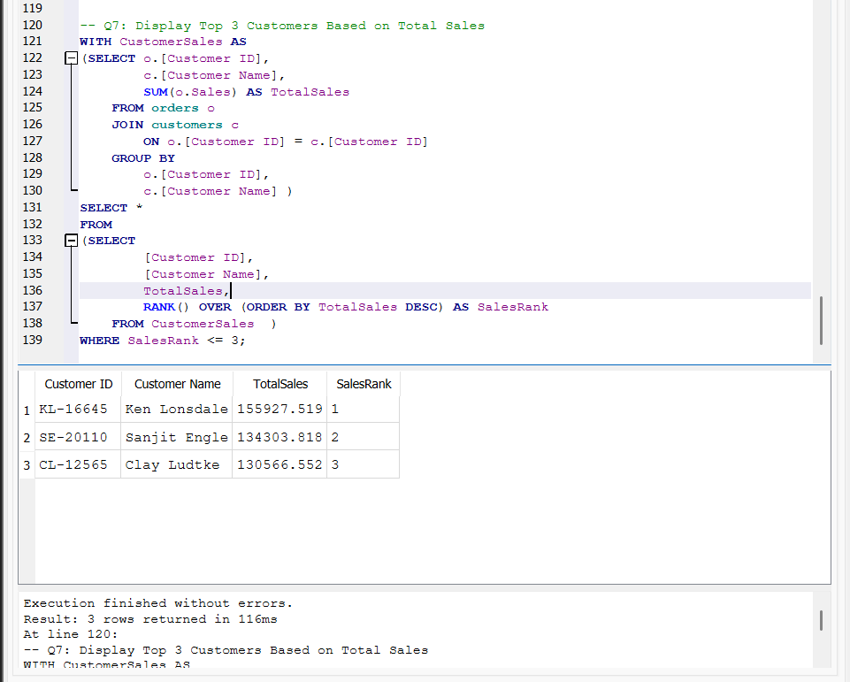
The top three customers based on total sales were identified using a window function. These customers contribute significantly to business revenue and can be targeted with premium services and personalized offers.

Step 3: Final Combined Query
Write one final query that shows:
- Customer Name
- Total Sales
- Rank
